CIS CAT -REPORT (Null class intern TASK 1)
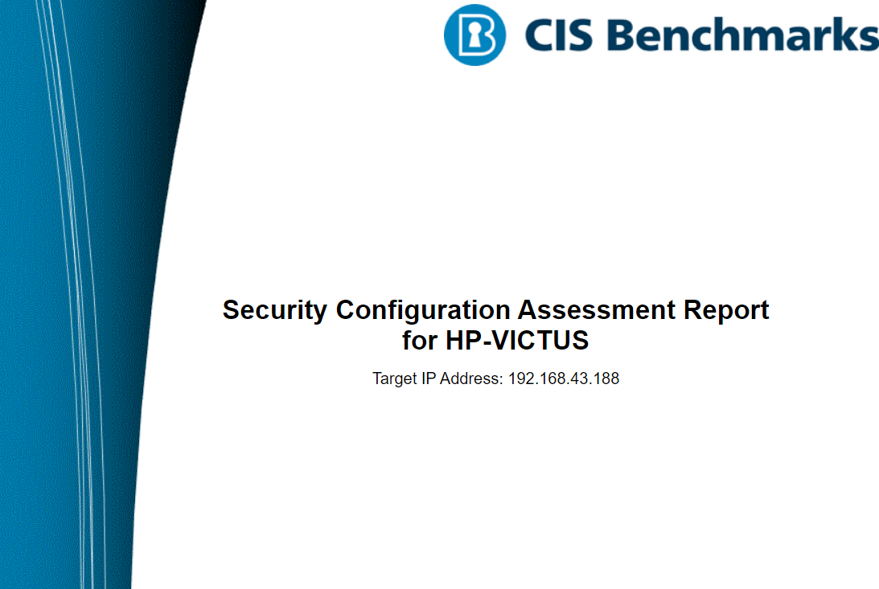

CIS Microsoft Windows 10 Enterprise Benchmark v3.0.0

Level 1 (L1) - Corporate/Enterprise Environment (general use)

Monday, October 7 2024 19:30:01

Assessment Duration: 1 minute, 21 seconds.

NAME : MADHUMITHA.B

TITLE : Learn To Hack Real -Time operating system internship.

COMPANY NAME : NULLCLASS

REPORT

- System: LAPTOP-HP VITCUS.
- Date: Monday, October 7 2024 19:30:01.
- Assessment duration: 6 minute, 21 seconds.
- Benchmark: CIS Microsoft Windows 10 Enterprise Benchmark v3.0.0.
- Level: Level 1 (L1) - Corporate/Enterprise Environment (general use).
TABLE OF CONTENT

- Introduction .
- Executive Summary .
- Initial Assessment Results.
- Proofs Of Assessments .
- Methods and steps involved.
- Conclusion and Recommendations.
INTRODUCTION

PURPOSE OF CIS -CAT ACCESSOR

- Benchmark Assessments: Evaluates systems against established security benchmarks to ensure compliance with best practices.
- Vulnerability Identification: Detects potential vulnerabilities and misconfigurations to enhance security.
- Compliance Reporting: Generates reports for audits, documenting adherence to security standards.
- Automated Testing: Automates assessment processes for consistency and efficiency.
- Improving Security Posture: Facilitates necessary changes to bolster overall security.
- Tracking Progress: Monitors improvements over time by comparing assessment results.
- Encouraging Best Practices: Promotes security best practices within organizations.

- System Coverage: Assesses various operating systems and applications based on CIS benchmarks to identify vulnerabilities and compliance gaps.
- Automated Assessments: Conducts thorough evaluations through automated checks, providing detailed insights into security configurations and practices.
- Reporting and Recommendations: Generates comprehensive reports that highlight findings, compliance levels, and actionable recommendations for improving security posture.

SCOPE

SUMMARY

2nd ASSESSMENT SCORE:34%
1st ASSESSMENGT SCORE :14%

PROFILE INFO

- The CIS Microsoft Windows 11 Enterprise Benchmark contains 5 profiles out of which Level 1 (L1) - Corporate/Enterprise Environment (general use) profile was used for this assessment.

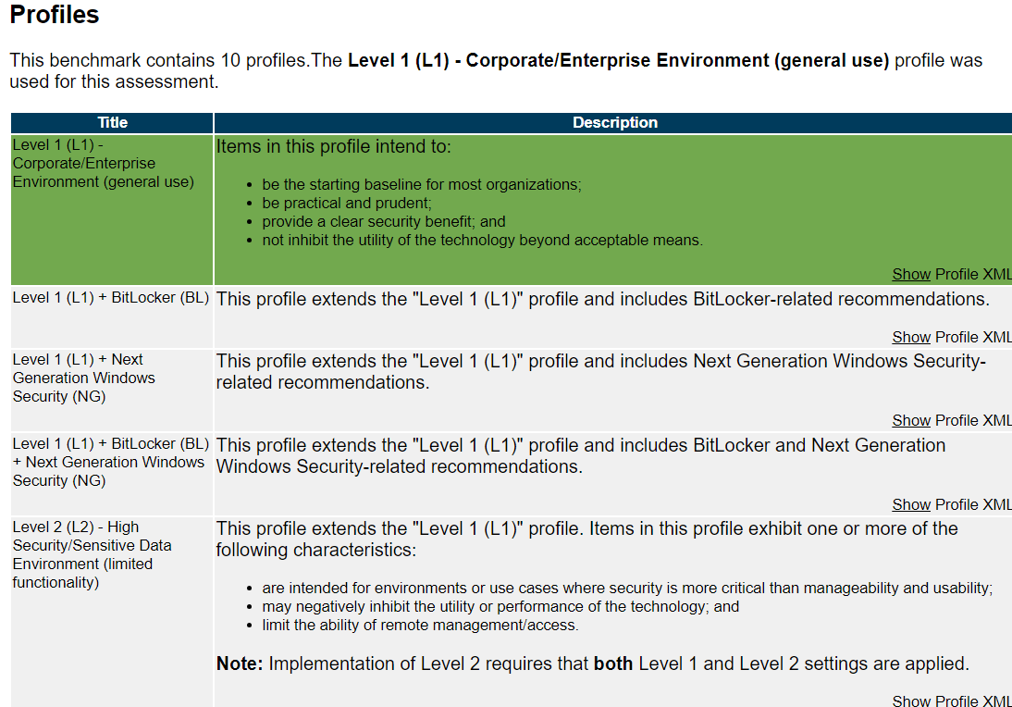

SUMMARY OF IMPROVEMENT DETAILS

- Configuration Hardening: The assessment revealed numerous configuration settings that require hardening to align with best practices outlined in the CIS Benchmark. Implementing these changes will help mitigate vulnerabilities and enhance overall system security.
- User Access Controls: The results highlighted weaknesses in user access management, including unnecessary permissions for certain user accounts. Strengthening user access controls by following the principle of least privilege will reduce the risk of unauthorized access and potential data breaches.
- Patch Management: The assessment indicated that several critical patches and updates were not applied, leaving the system vulnerable to known exploits. Establishing a regular patch management schedule will ensure that systems are kept up-to-date and secure against emerging threats.
1st ASSESSMENT PROFF &2nd ASSESSMENT PROFF

METHODS AND STEPS
- Preparation Phase:
  - Tool Selection: Chose the CIS-CAT Lite tool for conducting the security assessment based on its capability to evaluate systems against the CIS Benchmarks.
  - Environment Setup: Ensured that the assessment environment was ready, which included having administrative access to the systems to be evaluated.
- Configuration Assessment:
  - Baseline Configuration: Selected the relevant CIS Benchmark for the operating system or application in use.
  - Initial Scanning: Executed the initial scan using the CIS-CAT Lite tool to evaluate the current configuration against the benchmark settings.
- Result Analysis:
  - Review of Results: Analyzed the assessment results, focusing on the total number of checks, passed checks, failed checks, and informational findings.
  - Identification of Vulnerabilities: Identified specific vulnerabilities and misconfigurations that contributed to the failed checks.
- Documentation:
  - Reporting: Generated a comprehensive report outlining the assessment findings, including detailed explanations for each failed check and recommendations for remediation.
  - Summary of Findings: Compiled a summary of the overall security posture based on the assessment results, highlighting critical areas that require immediate attention.
- Remediation Planning:
  - Actionable Steps: Developed a remediation plan detailing actionable steps for addressing the identified vulnerabilities, including configuration changes, user access adjustments, and patch management procedures.
  - Implementation: Collaborated with relevant teams to implement the recommended changes and improvements based on the assessment results.
- Follow-Up Assessment:
  - Reassessment: Planned for follow-up assessments to verify the effectiveness of the implemented changes and to ensure continuous improvement in the organization’s security posture.

PROOF

- Example: PASSWORD POLICY, Minimum of 24 password history to be saved.
- Computer Configuration\Policies\WindowsSettings\Security Settings\Account Policies\Password Policy\Enforce password history

CONCLUSION
- The CIS-CAT Lite assessment conducted on the system revealed significant gaps in compliance with the CIS benchmarks, as demonstrated by a pass rate of only 14%in 1st setup. A total of 278 configuration checks failed, indicating potential vulnerabilities and security weaknesses that could be exploited. This highlights the need for immediate action to strengthen the system’s security posture and ensure compliance with industry best practices.

- However, in 2nd assessment the pass rate were increased to 34%and this assessment provides a clear roadmap for improvement by pinpointing specific areas where configuration changes are required. Addressing these failures will greatly enhance the security of the system, reduce risk exposure, and move the organization toward achieving full compliance with CIS benchmarks.
RECOMMENDATIONS

- Prioritize Critical Issues:
  - Focus on addressing the most critical and high-priority configuration failures that pose the greatest risk to the system. Immediate attention should be given to vulnerabilities that could be exploited for unauthorized access or data breaches.
- Implement CIS Benchmark Guidelines:
  - Adopt the configuration recommendations provided by the CIS benchmarks, particularly in the areas of user access control, patch management, and security settings. Ensuring compliance with these guidelines will greatly reduce the attack surface.
THANK YOU

